Coordinated Entry Workflow Document
Referring a client to coordinated entry
- Creating the referral
- Navigate to the client’s file in Clientpoint
- When you enter the client file you need to first go to the “Service Transactions” tab.
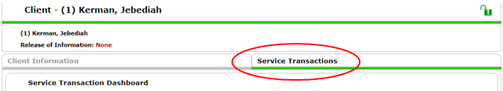
- Click on the “Add Referrals” box.
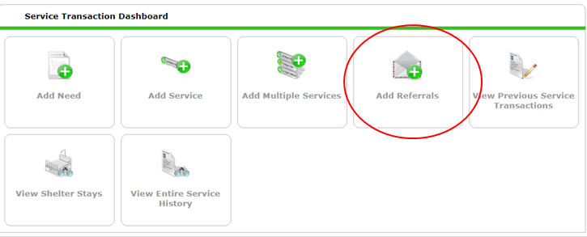
- Select the entire family or just the individual by checking the box next to all individuals being referred in the household.
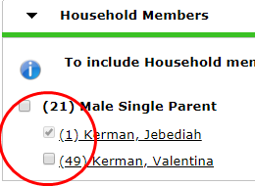

- Select the Service you are referring the client/ family for. Select either “Homeless Permanent Supportive housing”, “AIDS/HIV Control”, or “Rapid Rehousing” ONLY. If the Services are NOT there, ask your agency administrator to add them.
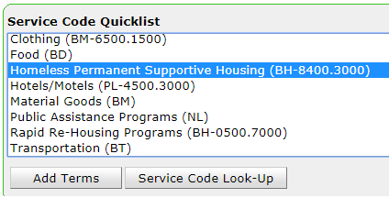

- Highlight the appropriate service and click “Add Terms” button. 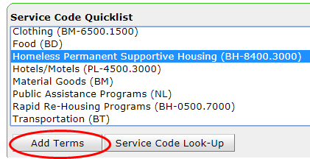

- Select the “Coordinated Entry NY-505” provider from the Referral Provider Quicklist
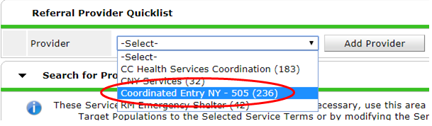

- Scroll down the page to complete the “Referral Data” section. Ignore the “Search for Providers” section.
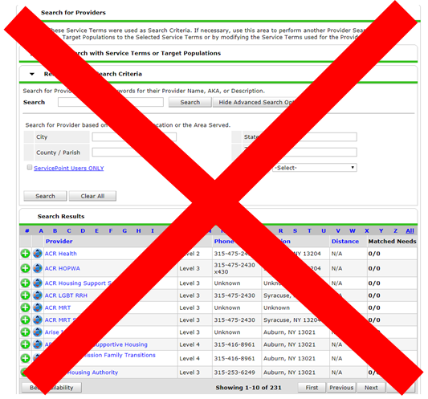
- Next, add the appropriate VI-SPDAT to the referral. ALL Coordinated Entry referrals must have the VI-SPDAT attached to them. Remember:
  - VI-SPDAT – is a referral for single adults 25 years of age or older.
  - TAY-VI-SPDAT is for single youth ages 16 to 24 years of age.
  - VI-FSPDAT is for Families, even families where the Head of Household is 24 or under.
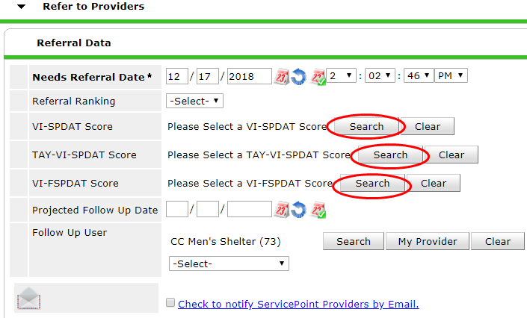

- After clicking on the “search” button next to the appropriate VISPDAT type, select the most recent VI-SPDAT assessment that has been completed for the individual or family.
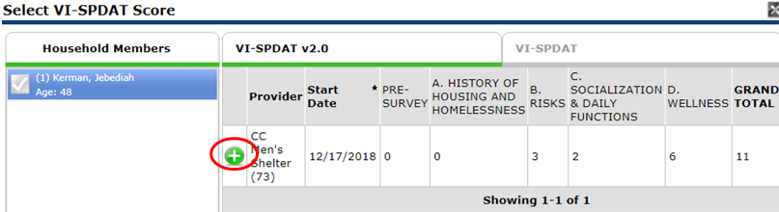
- The VISPDAT total score will now appear in the referral data section.
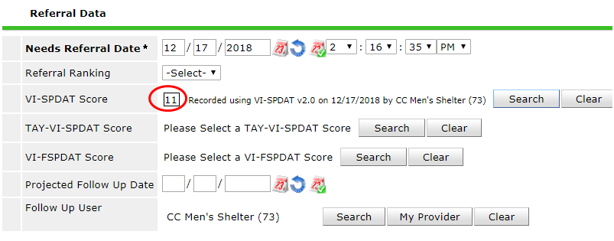
- The “Check to notify Service Point Provider by Email” should not be checked. This will send a referral to the Contact Person listed in the Provider Profile.
- Make sure that the check box is filled in for the Referrals portion of the transaction.
- Click “Save All” at the bottom of the page.
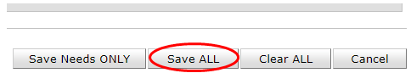

- You can always check on the Status of your referrals by going into HMIS Service Transactions. Please note the “Need Status” and “Outcome” columns.
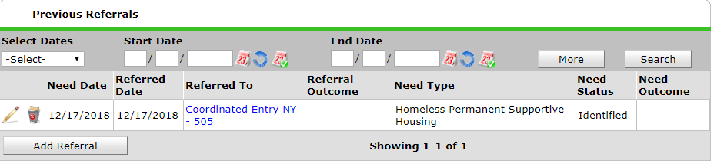
Continue to Part B. Completing the Coordinated Entry Assessment
- Completing the Coordinated Entry Information Assessment
- Navigate to the assessments tab
- Select the “Coordinated Entry Information” assessment
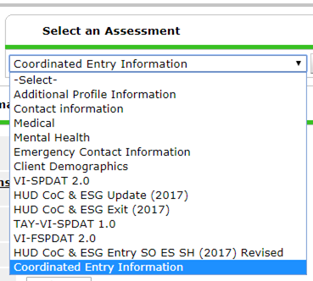
- Fill in the first 4 fields. (Date assessment was updated, months homeless, county preferred, and ESG) are required.
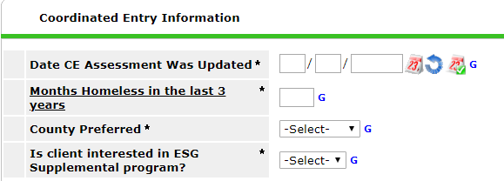
- If you are reviewing the coordinated entry assessment information and the fields in bold are incorrect, change them on the assessment.
- All questions that is after the ESG question should have already been answered on the intake assessment. They are not in bold text on the CE information assessment. If the fields not in bold are incorrect, change them on the most recent intake assessment, or create an Update interim review and change them. DO NOT CHANGE THEM IN THE ASSESSMENTS TAB.
- Click “save” assessment. You will not be able to save the assessment unless you have answered the 4 required questions.
- Review this information once a month for all active clients.

