Coordinated Entry Workflow Document – HHC of Central New York
Referring a client to coordinated entry
- Creating the referral
- Navigate to the client’s file in Clientpoint
- When you enter the client file you need to first go to the “Service Transactions” tab.
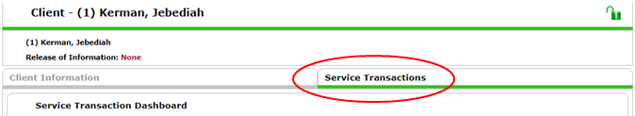
- Click on the “Add Referrals” box.
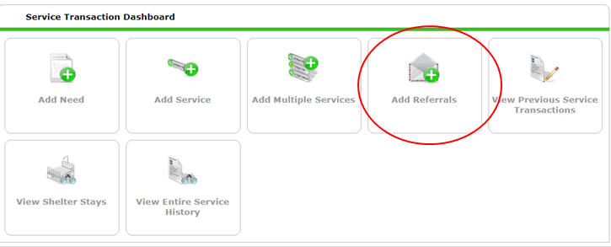
- Select the entire family or just the individual by checking the box next to all individuals being referred in the household.
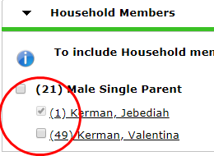

- Select the Service you are referring the client/ family for. Select either “Homeless Permanent Supportive housing”, “AIDS/HIV Control”, or “Rapid Rehousing” ONLY. If the Services are NOT there, ask your agency administrator to add them.
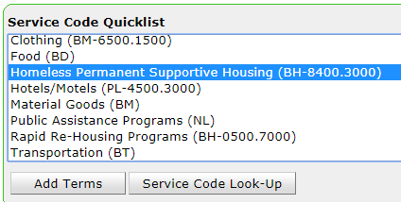

- Highlight the appropriate service and click “Add Terms” button. 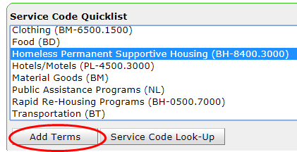

- Select the “Coordinated Entry NY-505” provider from the Referral Provider Quicklist
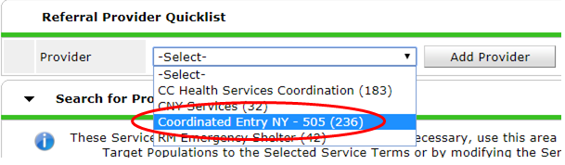

- Scroll down the page to complete the “Referral Data” section. Ignore the “Search for Providers” section.
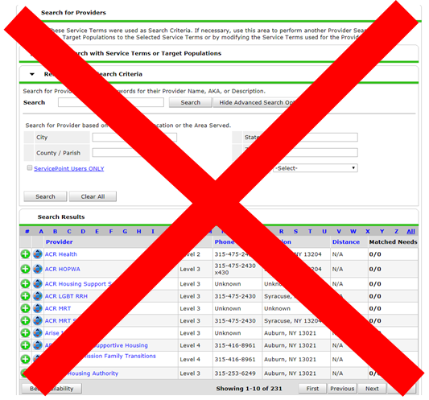
- Next, add the appropriate VI-SPDAT to the referral. ALL Coordinated Entry referrals must have the VI-SPDAT attached to them. VI-SPDATs should be added in the assessments tab prior to making the referral. Remember:
  - VI-SPDAT – is a referral for single adults 25 years of age or older.
  - TAY-VI-SPDAT is for single youth ages 16 to 24 years of age.
  - VI-FSPDAT is for Families, even families where the Head of Household is 24 or under.
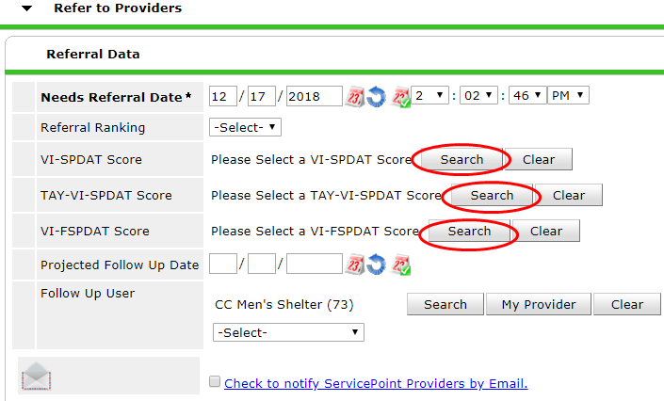

- After clicking on the “search” button next to the appropriate VISPDAT type, select the most recent VI-SPDAT assessment that has been completed for the individual or family.
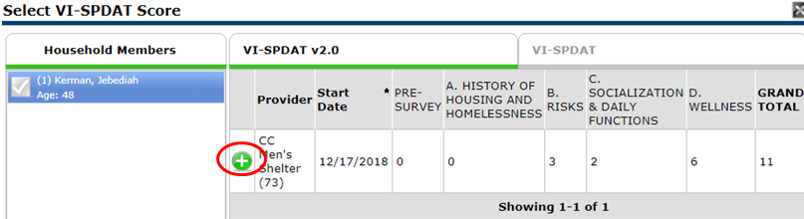
- The VISPDAT total score will now appear in the referral data section.
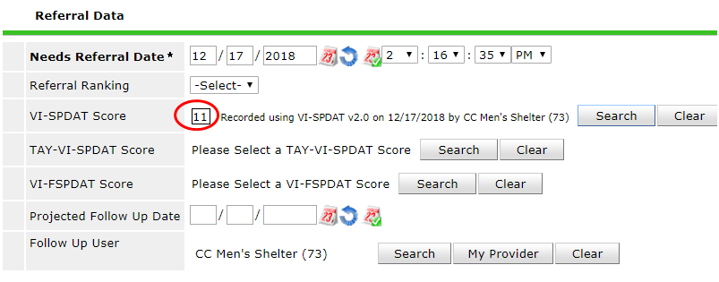
- The “Check to notify Service Point Provider by Email” should not be checked. This will send a referral to the Contact Person listed in the Provider Profile.
- Make sure that the check box is filled in for the Referrals portion of the transaction.
- Click “Save All” at the bottom of the page.
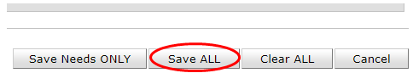

- You can always check on the Status of your referrals by going into HMIS Service Transactions. Please note the “Need Status” and “Outcome” columns.
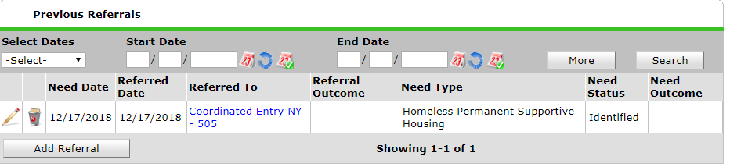
Continue to Part B. Completing the Coordinated Entry Assessment
- Completing the Coordinated Entry Information Assessment
- Navigate to the assessments tab
- Select the “Coordinated Entry Information” assessment
Note: Your Enter Data As provider must be the shelter or outreach provider that is providing the referral to see the Coordinated Entry Information Assessment listed.
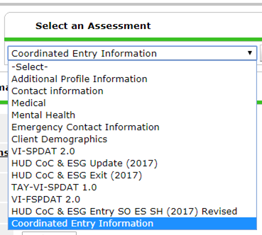
- Fill in the first 4 fields. (Date assessment was updated, months homeless, county preferred, and ESG are required for all referrals). Chronic PSH referrals and Family referrals have additional questions required for only those referrals.
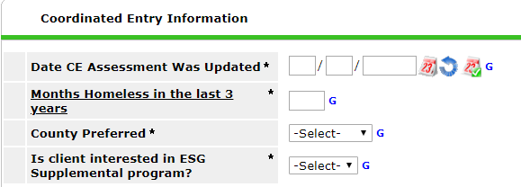
- If you are reviewing the coordinated entry assessment information and the fields in bold are incorrect, change them on the assessment.
- All questions that are after the ESG question should have already been answered on the intake assessment. They are not in bold text on the CE information assessment. If the fields not in bold are incorrect, change them on the most recent intake assessment, or create an Update interim review and change them. DO NOT CHANGE THEM IN THE ASSESSMENTS TAB.
- Click “save” assessment. You will not be able to save the assessment unless you have answered the 4 required questions.
- Review this information once a month for all active clients.
- Closing Referrals
When to close referrals:
I. If you are a housing provider accepting the client into your program, you will accept the coordinated entry referral in the system and provide a service for the type of service the referral was made for.
II. If you are a shelter/ street outreach case manager ending the client’s referral, you will cancel the coordinated entry referral under these circumstances:
A. The client finds permanent housing without a subsidy or financial assistance from the coordinated entry system and is no longer homeless (e.g., not in a rapid rehousing or permanent supportive housing program)
B. The client has left the shelter/streets and has not had any contact with you for 90 days.
C. The client has been accepted into a program of a different type than the referral. For example, you may have to cancel a referral for rapid re-housing if a client goes into a permanent supportive housing unit.
D. The client has a duplicate referral made, and one of them has already been closed.
1. Double check that your Enter Data As provider is the provider who is closing the referral!!!
- Navigate to the Referrals section of the client’s page by selecting “Service Transactions” -> “View Entire Service History” -> “Referrals”
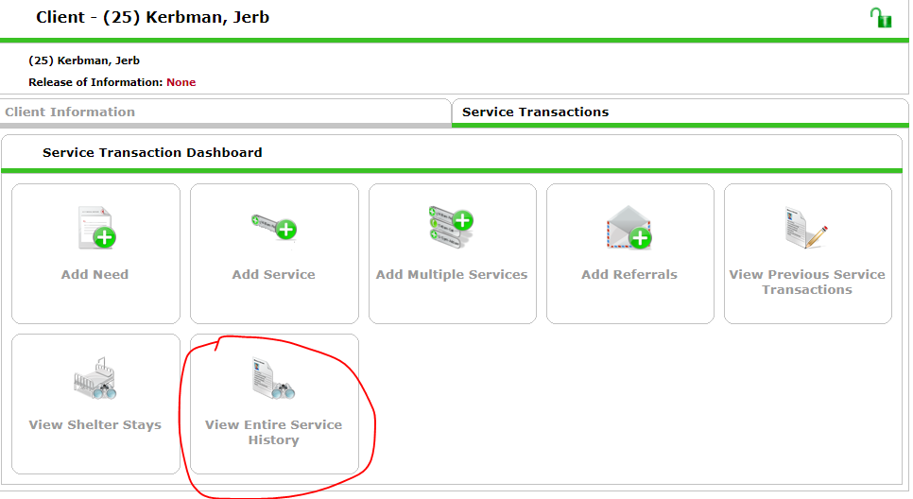
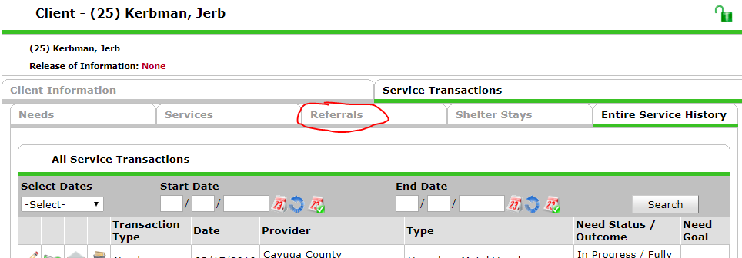

- Select the Pencil next to the referral that needs to be closed. Check that it is the referral you are looking for by examining the Need Type, the Referral outcome, and the Need Status and Outcome. The Referral Outcome and Need Outcome will be blank, and the need status will be “Identified” or “In Progress” if the referral is not closed.
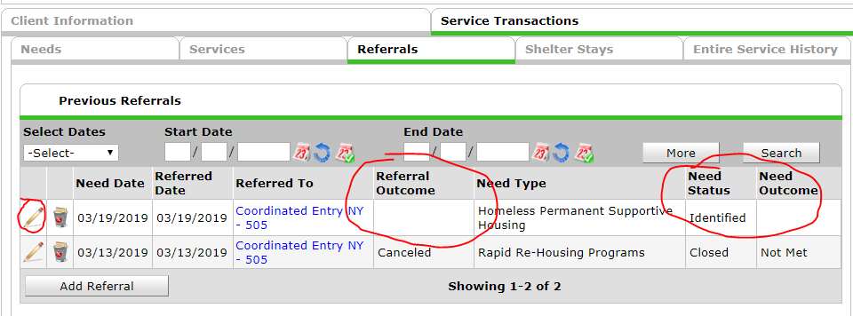

- Change the “Referral Outcome” to “Accepted” or “Canceled” in the “referral Data” Section
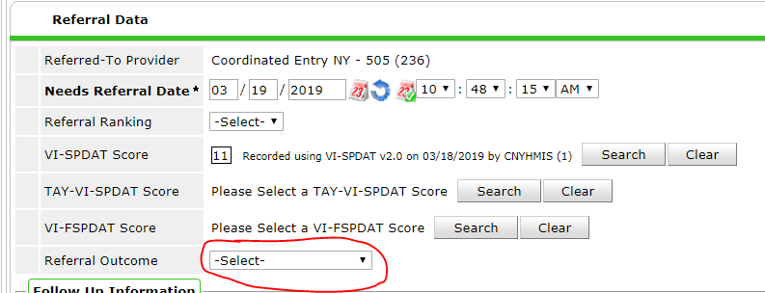

- Change the “Need Status” to “Closed” , and the “Outcome of Need” to “Fully Met” or “Not Met”.
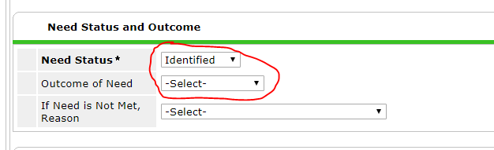
- If you are an emergency shelter or outreach provider, you have closed the referral. Click “Save & Exit” to return to the referrals menu.
If you are a housing services provider, You must also provide a service to close out the referral.
- Click the “provide service” button after Service information. This will take you to an Add Service screen.
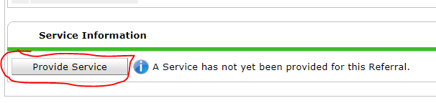
- Change the Start Date to the date that the client entered your project.
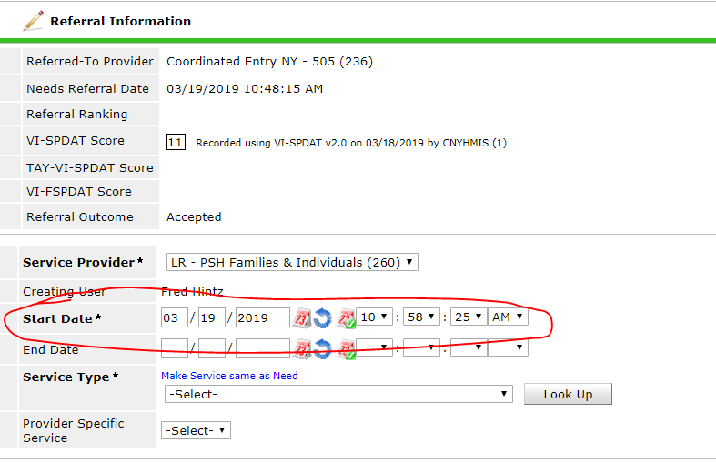

- Click “Make Service same as Need” to make the Service Type the same as the Need Type.
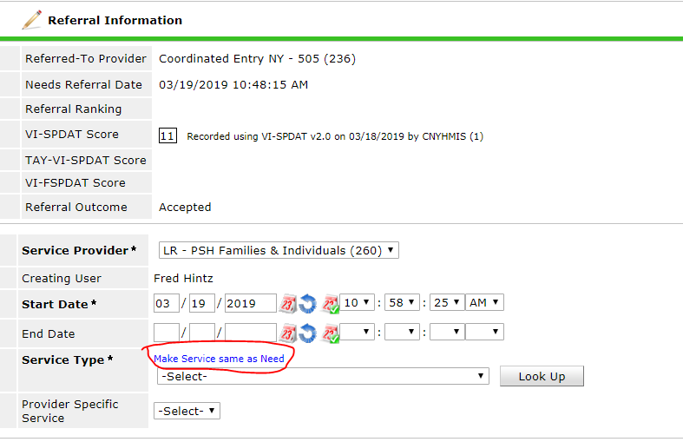

- When the start date and need type are appropriate, click “Save & Continue”
- On the following screen, change the need information to “Closed” and the outcome of Need to “Fully Met”
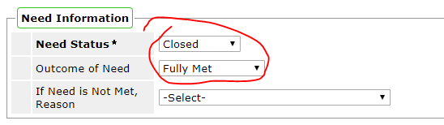
- Click “Save & Exit” to save the service.

