Housing providers are required to do 2 tasks in the coordinated entry process
- Record their contacts with clients that are matched with their program.
- Close “Coordinated Entry” Entry/Exits after clients are housed.

Recording Contacts With clients.
Note: Providers in Oswego or Cayuga county should use their county-specific provider. This document will refer to all 3 providers as “Coordinated Entry NY-505”.

- Change your “Enter Data As” provider to the “Coordinated Entry NY-505” provider
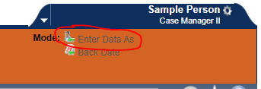
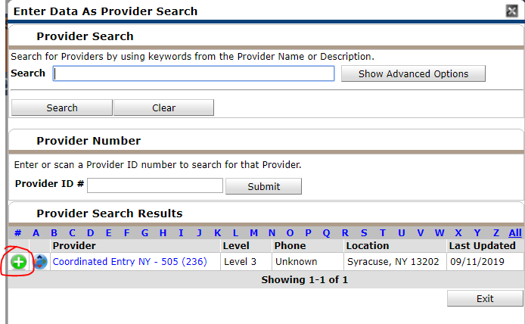
- Navigate to the client’s profile in Clientpoint
- Navigate to the Entry/Exit Tab of the client’s profile
- Create a new Interim Assessment in the Client’s Coordinated Entry Entry/exit
  - If the Client does not have an open CE entry, contact the caseworker at the referring shelter or street outreach program as well as the appropriate coordinated entry staff person.
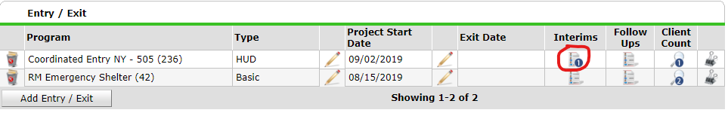
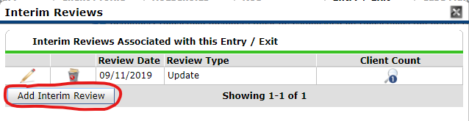
- Select “Update” as the type of interim assessment, and set the Review date to the date of the contact.
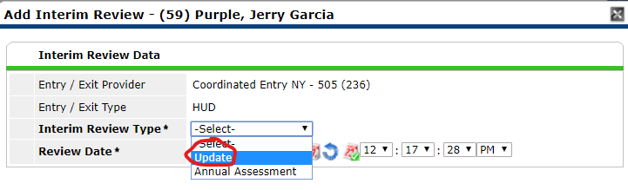
- Confirm that “Matched Provider (CE Staff Only)” Has your program listed as the housing provider matched to this client, and contact CE staff if your program is not listed here.
- Add a new record to “Housing Provider Contacts”
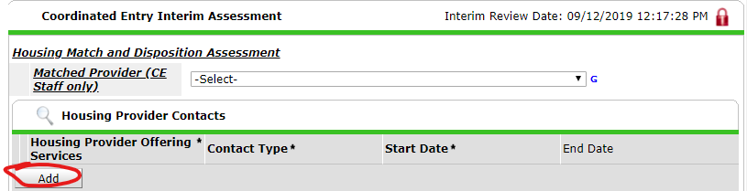
  - Select your provider as “Housing Provider Offering Services”
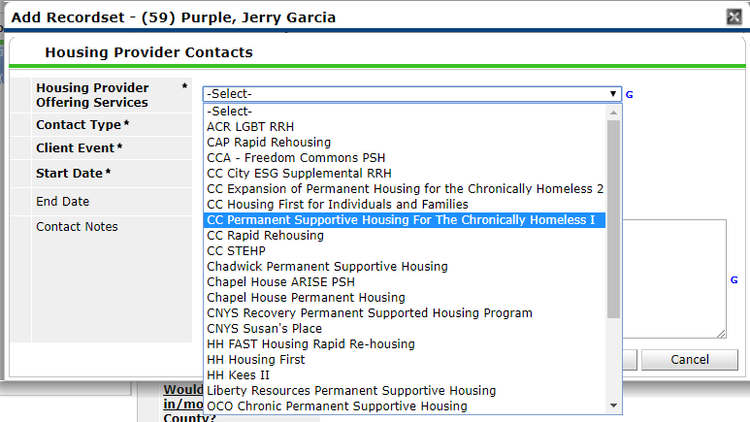
  - Select the appropriate Contact Type
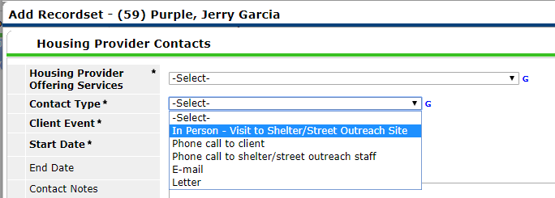
  - Select a client Event describing the outcome of the contact.
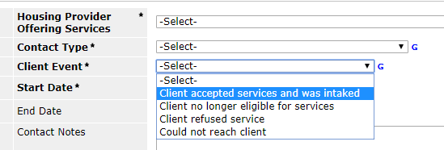
  - Ensure that the Start Date is the date the contact occurred.
  - Fill out any additional information about the contact in “Contact Notes”
- Save and Exit the interim assessment

Closing “Coordinated Entry” Entry/Exits.
- Change your “Enter Data As” provider to the “Coordinated Entry NY-505” provider
- Navigate to the client’s profile in Clientpoint
- Navigate to the Entry/Exit Tab of the client’s profile
- Click on the pencil to the left hand side of the blank “Exit date” column to edit the client’s exit.
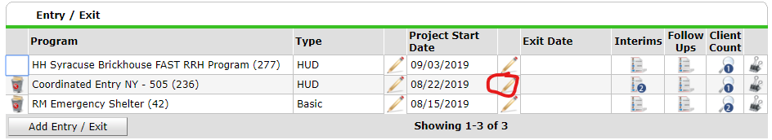
- Select the appropriate exit date and destination for the Coordinated Entry provider.
  - Rapid Re-housing providers should exit clients’ Coordinated Entry referrals when they have moved in to a housing unit, and select the “Rental By Client, with RRH or equivalent subidy” destination.**
  - Permanent supportive housing providers should close clients when they move into housing units with their programs, which should coincide with the start date in that project. They should select the “Permanent housing (other than RRH) for formerly homeless persons”.
**Clients who are chronically homeless at RRH intake and are being considered for PSH while living in their housing unit should be left open.
- Save and continue through that screen, and confirm that the “Matched Provider” on the exit assessment is your provider. 