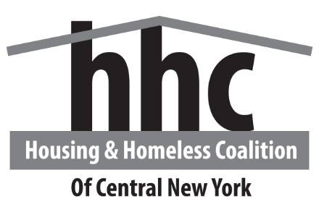
Homelessness in Central New York
Data from the CNY HMIS - https://tabsoft.co/2XpM71h
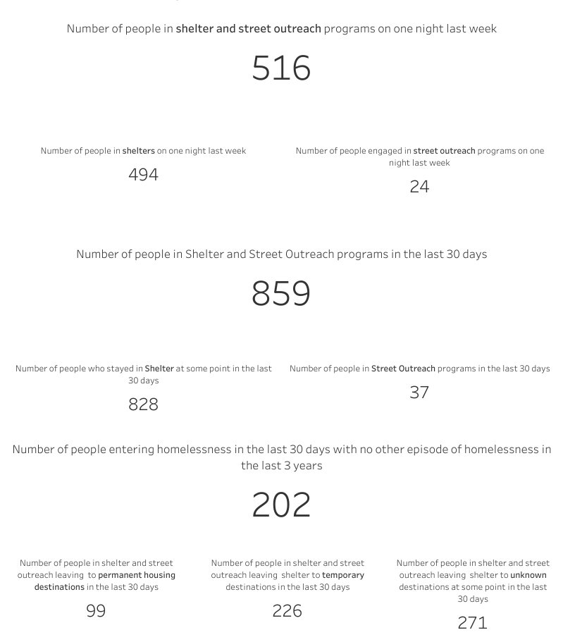

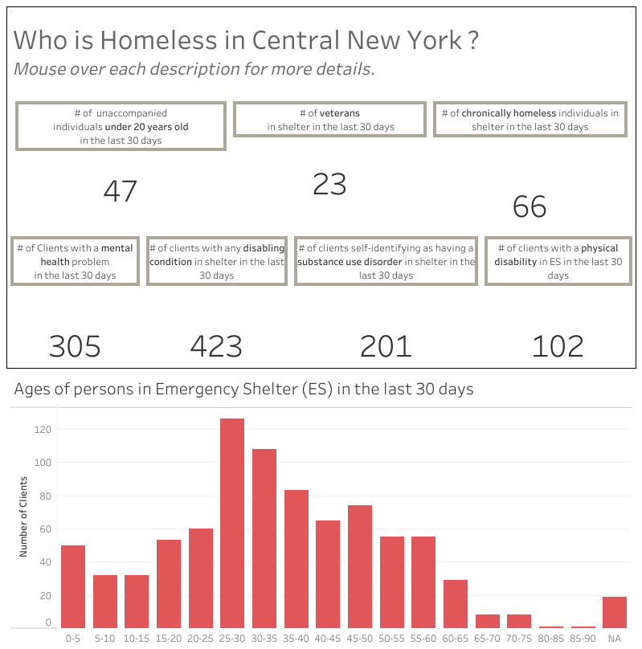

The Housing & Homeless Coalition of CNY ("HHCCNY") Data Dashboard is intended for informational purposes only. This Data Dashboard is presented to provide a summary of data related to homelessness in our region that HHCCNY member organizations report in our Homeless Management Information System (HMIS). The HHCCNY disclaims all responsibility for the accuracy, completeness, or currentness of the data contained in the Data Dashboard. Additionally, the Data Dashboard does not include information from all member organizations and it does not include information from non-member organizations, therefore it is not a complete picture of homelessness in our region. The Data Dashboard is meant to inform conversations regarding assessing community needs and developing comprehensive community strategies to reduce, prevent and ultimately end homelessness and housing vulnerability in our community.

