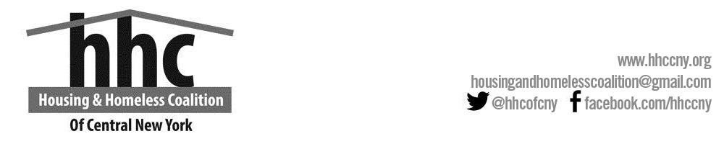

**HHC ADVISORY BOARD MEETING MINUTES**

Tuesday, July 16, 3:00pm-4:30pm

Reisman’s Room

980 James Street, Syracuse, NY. 13203

* Welcome and Introductions-Present Allison Brooks, Megan Stuart, Sarah Schutt, Fred Hinz, Amber Vanderploeg, Sue MacMahon, Marty Skahen, Sally Santangello, Renae Jensen, Sonja Gottbrecht, Larkin Podsiedlik, Marlene Klock, Kelly Gonzalez, Ben Lockwood, Marteen Jacobs, Diane Cooper and Liz Vuillemot joined via zoom.
* Approval of Minutes from May 2019 meeting.

Minutes for May 2019 was approved.

* NOFA Presentation

1. Megan Stuart-NOFA Deadline is Tuesday, September 30th, 2019 and detailed information for 2019 NOFA.
2. Megan Stuart- outlined the responsibilities and duties of the Performance Evaluation and Selection Committee.

* Coordinated Entry Project

1. Fred Hinz- HUD expects all clients served by the Homeless Service System be inputted into the system. Though currently not the practice, effective tracking will help to improve services since their focus will be entirely on Coordinated Entry.
2. Sue MacMahon-requested more information on the job description of the CE person.
3. Allison Brooks-wanted to know about other counties who had hired a CE person and how that was working out.
4. Sonja Gottbrecht moved the motion on applying for a CE position.

* Tompkins Country HMIS

1. Sarah Schutt-Tompkins County currently has challenges with their HMIS (Client Track).
2. Sarah Schutt-We would provide training, LSA, overseeing data quality, APR, technical assistance, etc.
3. Sonja Gottbecht-What are the benefits for our county?
4. Amber Vanderploeg- depicted a grim picture of Tompkins County’s commitment to ensuring an effective system based on her personal and professional experience.
5. Allison Brooks—we need to clarify their role in the budget.
6. Sue McMahon- We need to get a lawyer who would look at the budget and ensure that the legal implications are taken care of.

* ESSHI/ Community Priorities

1. Sarah Schutt- explained the NY-505 Homeless Population Assessment data, in terms of population beak down, age, race, disabling condition and victims/survivors of Domestic Violence.
2. Megan Stuart- We no longer need Veterans’ projects; our current capacity is working well.

* Business Matters

1. Financial Report
2. There’s no financial report.
3. Data Analyst Description Review
4. Megan Stuart-Fred’s job description has been changed to Data and Systems Analyst to reflect the actual job he currently does.
5. Sally Santangello moved a motion to approve it; Allison seconded the motion.
6. Allison Brooks proposed we change the current time to 2:30pm.

* Board Committee Updates.

1. Performance Selection and Evaluation-
2. Marty Skahen- Meeting is on Thursday, July 18th2019 at 980 James Street. Time is 2:00pm.
3. Program Planning and Advocacy
4. Sally Santangello-The group will meet on August 21st, 2019 at 2:30pm.
5. Executive Committee-Meeting is on August 13th, 2019 at 3:00pm.

Adjourn

Next Board Meeting September 10th, 2019.