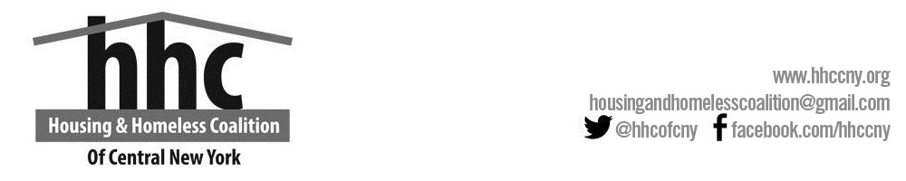
HHC Advisory Board Committee

Meeting Minutes

September 10, 2019

Opening
The regular meeting of the HHC Advisory Board Committee was called to order at 2:35 pm on September 10, 2019 in Reisman Room by Allison Brooks.

Present
Allison Brooks, Megan Stuart, Fred Hintz, Sarah Schutt, Dorcas Afenyo, Miranda Eddy, Joe King, Tim Donovan, Monica Brown, Sue McMahon, Stacy, Marty Jacobs, Sally Santangelo, Sally Curran, Tyreese, Lindsey. Diane Cooper-Currier, Renee Jensen, Liz Vuillemot, Mary Rathbun, Ben Lockwood via zoom

Approval of Minutes
The minutes of the previous meeting were unanimously approved as distributed.

Open Issues
Megan Stuart:
- Performance Evaluation and Selection Committee met last week. Due to new members, she explained how the tier system works in the NOFA.
- HHC did not apply for the Coordinated Entry Project grant due to not enough re-allocation funds. Also did not get RH funding.
- Announced an event for Hunger and Homeless Awareness week. Planned date is November 20th. Community Education Event- Joe, Monica, Sue and Tim volunteered to help with the education provided. HHC will be putting together a calendar spotlight.
Monica: Onondaga County is doing well. The financial audit had zero findings.
Sally Santangelo: questioned the amount for project K.E.E.S II. Fred explained the basis is due to the HUD scoring tool.
The motion was put forward to approve the project rankings for the NOFA applications. It passed unanimously. Joe King asked about the appeal process and Megan Stuart explained that there are two ways to appeal- to the committee or to NOFA itself.
The subject for strategies for affordable housing was brought forth. Megan stated that it would be helpful to have a vision for affordable housing and to be able to tell developers what is needed when they ask. Homeless preference was one, along with other specific preferences. Sally Santangelo suggested voucher preferences. An idea of a model for preference systems within the CoC and zero-residency requirements (more of a intra-city preference system) was suggested. Allison Brooks asked if maybe since applicants for eSSHI need a letter of support, that the CoC refuse a letter of support unless they agree to follow the policies of the preference system
Megan informed the committee that the NYS is tightening up their definition of the homeless. Monica presented the issue of housing stability for the mentally disabled and chemically dependent and how they go hand-in-hand for many of the homeless. In depth discussion continued with the main topic of educational training for landlords. Joe King suggested “volunteer” case management for those issues.
Megan wanted to bring all of the programs together and see what’s missing, along with what changes from county to county. Monica said one of the biggest issues is when people are placed in recovery programs that are outside of CNY, they come back with no where to go.
Developers and the needs for affordable housing was broached. Stacy mentioned that in Oswego County, the problem is mainly finding housing for previous incarcerated individuals or clients from rehab facilities. She was informed that Center of Community Alternatives is working on that very issue.
Sally Santangelo spoke regarding scattered sites and mixed income affordable housing being one of the major needs for the housing community at large. Allison brought up ESSHI for scattered sites. Sally Curran suggested maybe having a retreat for the coalition and putting together a work group to create the guiding questions to bring the answers for how to develop the scattered site development. The NIMBYism that is prevalent in the county is a barrier. Ben Lockwood spoke from a developer’s view on how scattered sites are nearly impossible due to getting permits in multiple locations and counties. Megan recommended the maybe we try to bring the counties together to see if they can streamline the process a little better. The consensus was for the coalition to bring experience and awareness so that the end goal to be affordable housing in different locations would be easier to achieve. The CoC was recommended to reach out to the bigger agencies like Catholic Charities, Salvation Army and Liberty Resources to help speed the process up, with the idea that the bigger agencies would be able to make more of an impact and create connections by communicating with the smaller agencies.

Sally Santangelo mentioned that the next Program Planning and Advocacy meeting would be on October 16 @ 1:30 pm at United Way. The focus for the meeting will be policy priorities and outreach to state legislators, particularly on expanding the protections for public assistance and housing.
Marty Jacobs spoke of the PES committee and since the selection has been made, that we will just wait to hear the complaints and appeals for the NOFA applications.
Megan informed the committee that United Way and the Syracuse Housing Authority would be working together on the vouchers for CoC’s supportive housing and trying to ensure that stable residents get priority for it.
A motion was put forth by Sally Curran to move to executive board, Sue McMahon 2nded and motion passed unanimously.

Adjournment
Meeting was adjourned at 3:53 pm by a motion from Joe King and 2nded by Sally Curran. The next general meeting will be at 2:30 pm on November 12, 2019, at United Way of Central New York.
Minutes submitted by: | Miranda Eddy
Approved by: | Name

