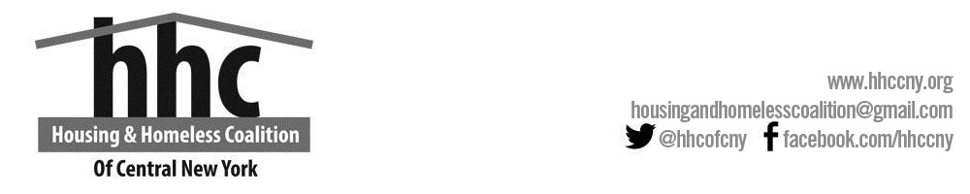

HHC GENERAL MEETING MINUTES
Wednesday, June 19TH, 2019
1:30pm-3:00 pm
Wegman’s Room
980 James Street, Syracuse, NY. 13203

- Welcome and Introductions- Meeting started at 1:34pm with the Chairperson Allison Brooks, welcoming and starting presentations.

- NYS Attorney General’s Office-Income Discrimination Law Review

Judy Markin and John Maas elaborated on the new review which highlighted consumer issues, car warranty, home and the availability of auctioneers for anyone who needed their services. Handouts will be out soon to educate the public.

- Changes to NYS Landlord/Tenant Law
- Sally Curan discussed some of the most immediately impactful aspects that we see in the law
- It now takes about 38 days to evict tenants.
- Landlords must provide written receipts.
- Tenant must be served 10-17days ahead of court (instead of 5-12 days)
- A tenant who goes to court and asks for adjournment shall be granted an adjournment of not less than 14days
- Questions? Contact: The Volunteer Lawyers Project of Onondaga County.

- Neighborhood and Business Development, City of Syracuse
Cali Khakoo and Liam Kirst passed around a survey to be filled out by all attendees.

- HHC Governance Charter-General Body Vote needed
Megan Stuart and Allison Brooks facilitated the voting process for the Rights and Responsibilities of the Advisory Board

- HHC Advisory Board Slate-General Body Vote Needed
Megan Stuart and Allison Brooks facilitated the Advisory Board Slate voting process.

- Continuum of Care NOFA Update
- Megan Stuart- Keep an eye out for the NOFA.

- HHC Committee updates
- Planning/Policy Committee-
- HUD Selection/Performance Evaluation-
- Cayuga County Committee-Auburn is looking for a new chair.
There is a lot of turnover in the county.
- Oswego County Committee-no updates
- Data Administrators Committee-Sarah Schutt announced they will be meeting on July 12th to update HMIS measures and procedures.
- Housing Service Providers Workgroup-Dorcas Afenyo announced upcoming trainings for the year.
- Runaway and Homeless Youth Workgroup-Joe King announced that the Salvation Army is getting recertified for a youth program for young ladies with kids.
- Amber Vander-Ploeg talked about an LGBTQ Shelter in the pipeline

- Outreach Workgroup
- Amber Vander-Ploeg encouraged members to call 211 if they see anything.
- Megan Stuart- A research fellow Barbara, met with all street outreach workers as part of a case study, to come up with best practices to end homelessness.

- Coordinated Entry Workgroup
- Fred Hinz informed attendees about forming a new group to review the VI-SPAT or use parts of it.
- Fred Hinz- As part of CE, new rules on how to track information (data standards) over the next year and hinted that we as a CoC might apply for a CE project in the next NOFA.

- Veterans Workgroup
- Jessica Hornings- the group meets once a month.

- Chronic Taskforce
- Jessie Butts gave an update about the number of people chronically homeless. The group meets once a month just before the Veterans group.

- Emergency Solutions Grant updates
- Sue McMahon-The 5-year plan is being drafted and inputs are welcome.

- Other quick updates from members
- Housing Advocate- announced a residential providers meeting.
- Renae Jenson- Been involved with Cayuga County CoC. Looking forward to joining Homeless Task Force.
- Kelly Gonzalez- Construction still ongoing at Freedom Commons.

