Coordinated Entry Workflow Document For Shelter / Street Outreach Providers:
Updated 9-13-2019
Note: Providers in Oswego or Cayuga county should use their county-specific provider. This document will refer to all 3 providers as “Coordinated Entry NY-505”.
Shelter and street outreach workers are required to:
-Create new “Coordinated Entry” Entry/Exit records for clients who are assessed and being considered for housing services.
-Update information once a month for clients who are continuously engaged with seeking services.
-Close old “Coordinated Entry” Entry/Exit records for clients who have not been engaged with services for over 90 days.
Creating a new Coordinated Entry Entry/Exit record:
- Change your “Enter Data As” provider to the “Coordinated Entry NY-505” provider
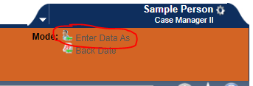
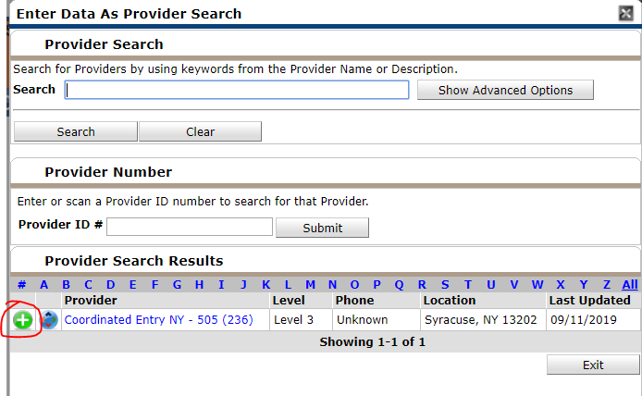

- Navigate to the Client’s profile in Clientpoint
- Add a Release of Information for the “Coordinated Entry NY-505” provider if the client agreed to share their information for coordinated entry on the CNYHMIS client consent form. Remember to add the ROI for all household members if a household is being referred.
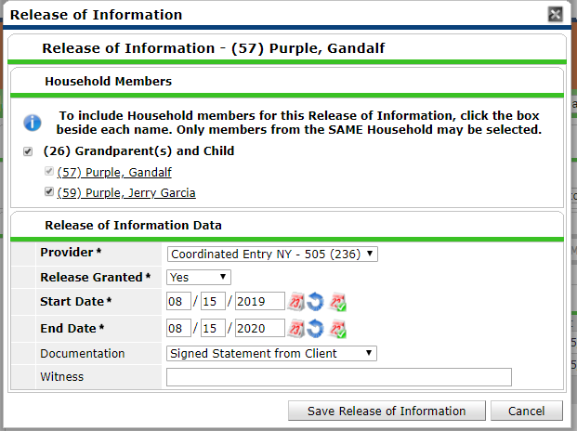
- Navigate to the Entry/Exit Tab, and add a new entry/exit for the “Coordinated Entry NY-505” provider on the date the client was assessed. Select “HUD” as the Entry Type. Remember to add the entry for all household members if a household is being assessed.
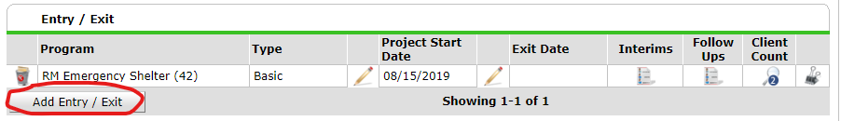
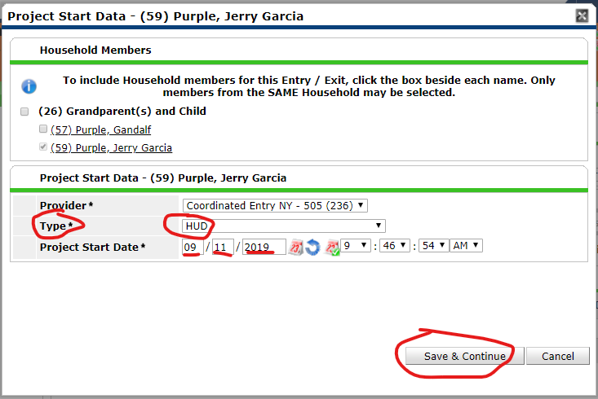

- Complete the Coordinated Entry Information Assessment
  - Complete the questions referring to clients interest in PSH, CoC RRH, and ESG RRH after discussing the program types with the client and cooperatively determining which would best suit the client’s needs.
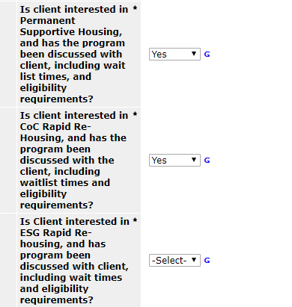
  - Complete the “Months homeless in the last 3 years” question. Caseworkers should use a combination of HMIS information along with a conversation with the client about their housing history in the last three years. This field is the primary prioritization metric for permanent supportive housing, but is not used in rapid re-housing prioritization. The value of this field should be greater than or equal to the answer on the most recent entry/exit assessment, which is shown at the bottom of this assessment. Assessments with inconsistent months homeless information will be placed on the errors list until they are corrected.
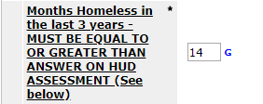
This is what the HUD question at the bottom of the assessment looks like:
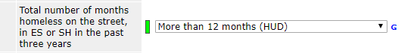
  - Complete the county preference questions. Only select a different county than their current location if you have discussed the implications of moving with the client.
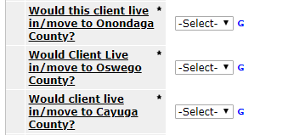
  - Complete Paperwork readiness questions.
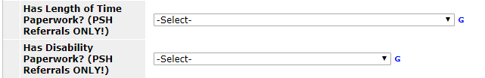
  - Complete Family Composition Question for households. Enter the age and gender of each member of the household, or state the number of bedrooms needed in the unit.
  - Enter a contact phone number for the client in the “Personal Telephone Number” field, if applicable.
  - Check that the client has the appropriate VI-SPDAT completed, and that the score is up to date.
  - Confirm that information being pulled from the most recent Intake assessments is as accurate as possible. If information is not accurate, please remember to change it on the most recent shelter or street outreach intake after you have completed the Coordinated entry assessment.
- Click “Save and Exit” to save the information and exit the assessment.

Updating Client Information on the Coordinated Entry Assessment
If any information on the Coordinated Entry assessment needs to be changed for a client before they have been matched with a program, it should be updated. Months homeless should be updated monthly for clients who are actively engaged with case management services.
To update client information, do the following:
- Change your “Enter Data As” provider to the “Coordinated Entry NY-505” provider

- Navigate to the client’s profile in Clientpoint
- Navigate to the Entry/Exit tab
- Click on the worksheet icon in the “Interims” column on the Entry/Exit page.
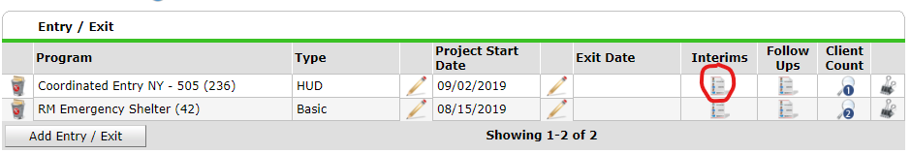
- Do not change the “Matched Provider” or “Housing Provider Contacts” sections.
- Update the questions that need to be changed on the assessment below, and check that questions at the bottom of the assessment taken from the shelter/street outreach intake form are still accurate for the client.
- Click “Save & Exit” to save the information and exit the assessment.

Uploading Documentation of chronic homelessness
To ensure consistent tracking of chronic homelessness and support efficient coordination of client services, the Housing and Homeless Coalition of Central New York now asking all participating emergency shelter, outreach, and supportive housing providers to upload documentation of chronic homelessness to HMIS for clients who are flagged for chronic homelessness. Clients must have signed a release of information for coordinated entry before this information can be shared.
What documentation should be uploaded?
- Self-certification of homelessness
- Self-certification of breaks in homelessness
- 3rd party verification of homelessness for time periods not otherwise documented in HMIS
- Disability documentation, preferably using the Coordinated Entry Verification of Disability Form or an SSA award letter
PDF versions of each of these forms are available on this web page on the section called “PSH Documentation Packet” : http://www.hhccny.org/coc/coordinated-entry/
HMIS instructions
- From the Servicepoint home screen, change your Enter Data As Provider to “Coordinated Entry NY-505”
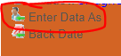
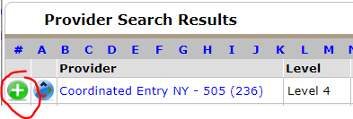
- Go to Clientpoint and enter the client’s HMIS ID number or name to navigate to their profile
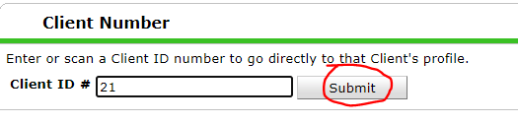
- Go to the “Case Plans” tab
- Under “Case Plans File Attachments” click “Add New File Attachment”
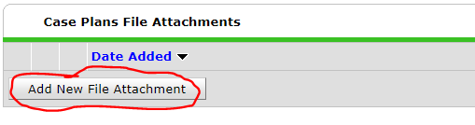
- Find the files that you have saved on your machine with the “Choose File” button, and add a description with the clients initials and the words “Chronic Documentation”, along with the date they were uploaded. Click upload to complete uploading the file.
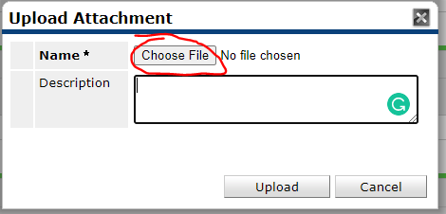

Note: Supported File Types
Several file types are supported as File Attachments in ServicePoint. The following common file types are supported:
- .pdf - PDF file
- .doc and .docx - Microsoft Word file
- .rtf - Rich Text Format file
- .txt - Plain text file
- JPEG (or JPG) - Joint Photographic Experts Group
- PNG - Portable Network Graphics
- GIF - Graphics Interchange Format
- BMP - Bitmap file
Audio and video files are not supported.

Closing CE Entries
Shelter or street outreach workers should close CE entries when clients have self-resolved, are housed outside of the coordinated entry system, or have not had contact with the shelter or street outreach program in 90 days. A list of clients who have not been in shelter or street outreach for 90 days is sent out each week with the coordinated entry prioritization list.
- Change your “Enter Data As” provider to the “Coordinated Entry NY-505” provider
- Navigate to the client’s profile in Clientpoint
- Navigate to the Entry/Exit tab
- Click on the pencil to the left hand side of the blank “Exit date” column to edit the client’s exit.
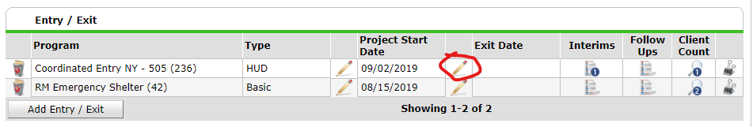
- Select the Exit date that is 90 days from their last contact with shelter or street outreach.
- Select the Client’s destination. Reason for leaving is not required.
  - If a client is housed independently of CoC or ESG programs and the worker filling out the exit knows that the client is housed, select as the reason for leaving and choose one of the following destinations that most appropriately describes their housing situation:
    - Rental by client, no ongoing housing subsidy (HUD)
    - Owned by client, no ongoing housing subsidy (HUD)
    - Staying or living with family, permanent tenure (HUD)
    - Staying or living with friends, permanent tenure (HUD)
    - Staying or living with family, temporary tenure (room, apartment, or house) (HUD)
    - Staying or living with friends, temporary tenure (room, apartment, or house) (HUD)
  - If a client exits to an institution that they have stayed in for more than 90 days, select one of the following destinations that most appropriately describes their housing situation:
    - Psychiatric hospital or other psychiatric facility (HUD)
    - Substance abuse treatment facility or detox center (HUD)
    - Hospital or other residential non-psychiatric medical facility (HUD)
    - Jail, prison or juvenile detention facility (HUD)
    - Foster care home or foster care group home (HUD)
    - Long-term care facility or nursing home (HUD)
  - If client loses contact with the shelter or street outreach team after 90 days and no information is available about their destination, select “No exit interview completed (HUD)”
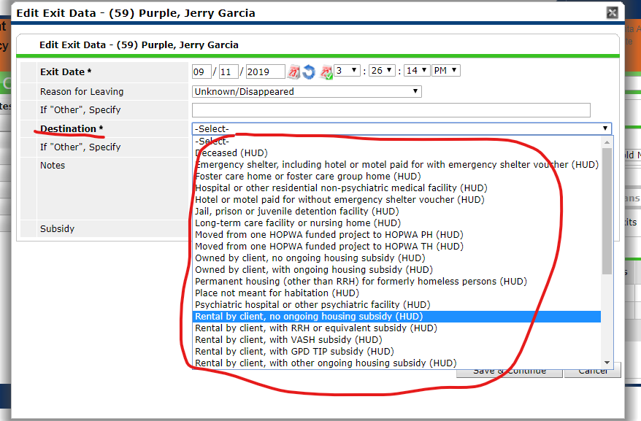
- Do not complete the Coordinated Entry Exit Assessment on the next page. Click Save and Exit.
