Documentation After Matching
How & When to Enter Contact Notes in Coordinated Entry in HMIS

Reminders and Important Time Frames
- The first contact attempt should be made within 3 business days of the match
- Clients have 2 calendar weeks (14 days including weekends and holidays) to respond to a housing project. This 2-week period begins from the date of the initial contact
- A minimum of 3 contact attempts and 4 notes are required for a client to be unmatched in the event of no response from client or Case Manager
1 – First contact attempt, done within 3 business days
2 – Second attempt, done around 1 week after first contact attempt
**Sometime between the second and third attempt please contact Ryan for assistance with connecting**
3 – Final contact attempt, done around 10 days after first contact attempt, be sure to include in message this is the final contact attempt and the deadline for the client to respond
4 – Note entered at 2-week mark indicating no response from client and request to be unmatched.
- Once this 4th note or another note requesting an unmatch for a valid reason is entered, you are free to submit this opening again for a new match. You can follow up with an email to be unmatched immediately or you will be unmatched during HHC match review (every 1-2 weeks). Please email if you have any questions surrounding a match or reason for unmatching.
- A contact note should be entered into an interim with a date matching the date the contact attempt was made. If an interim already exists for that date you can edit this interim, if one does not exist you will create a new one.
- In the case of no client/CM response a client will not be unmatched without the 4 notes outlined above. In the case of an unmatch for any other reason a note must be entered specifically requesting to be unmatched and for what reason.
- All notes should be related to contacts, intakes and rejections only. Please be conscious of relevancy to CE and client privacy when entering a note!

Step by Step Instructions
- As always before making any changes to a Coordinated Entry referral be sure you are entering data as Coordinated Entry NY-505.
The first section of this video review that process.
https://youtu.be/EzpRVtvY578?feature=shared
__________________________________________________________________
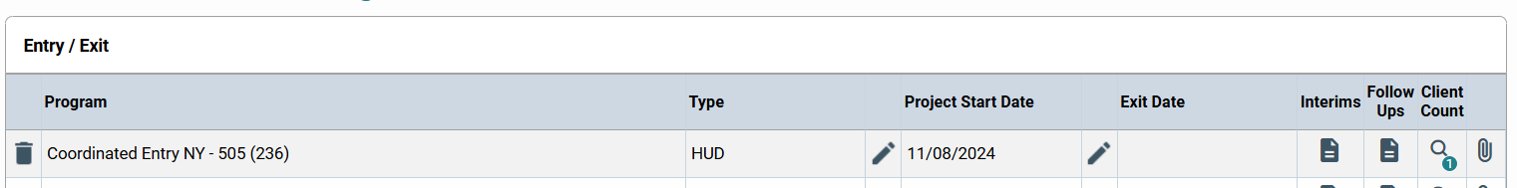
- Open the interims and create an interim for the date of the contact attempt, or if one already exists click the pencil to edit it
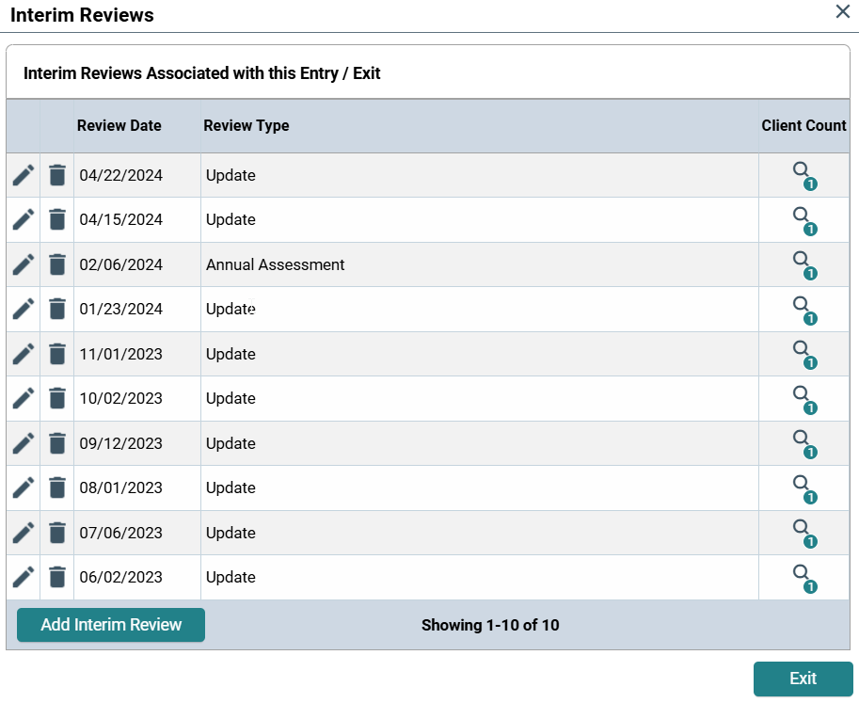

- Within the Interim locate the “Client Contacts (Housing Providers Should Update This Section)” section, then click add and enter in the appropriate information
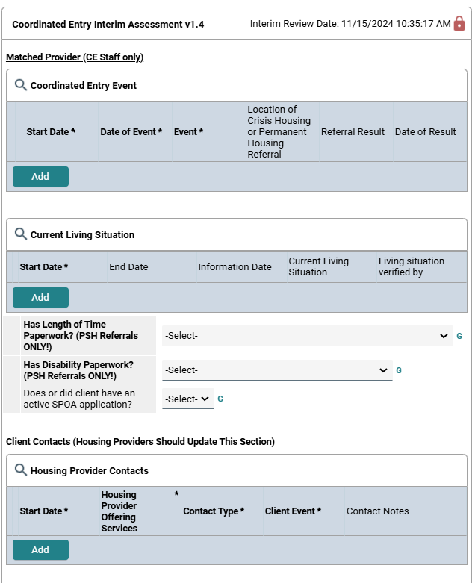

Example Notes
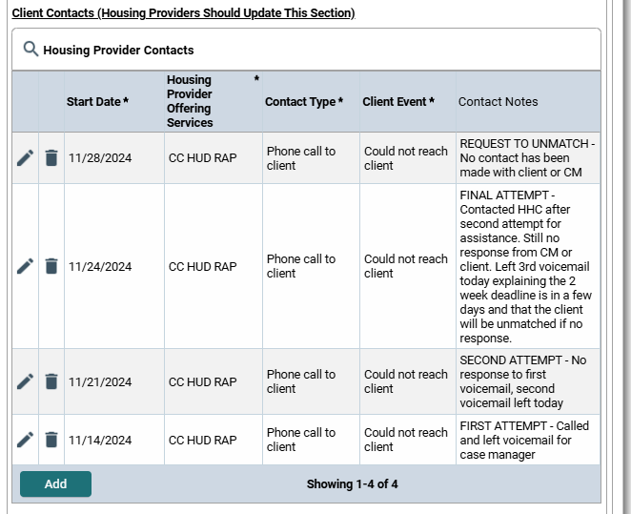
For a client matched on 11/12/2024 where neither the client or CM responded to the project

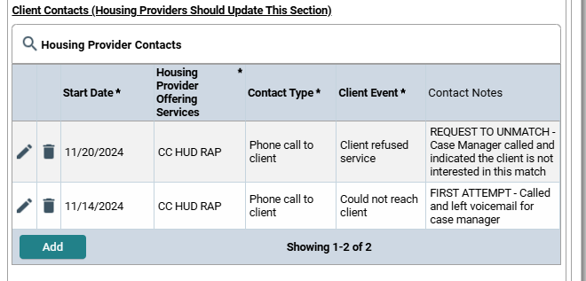
For a client matched on 11/12/2024 where the case manager responded to the initial contact attempt but indicated the client was not interested in the project

For a client matched on 11/12/2024 where the case manager responded to the initial contact attempt, an intake was scheduled and that intake was later completed
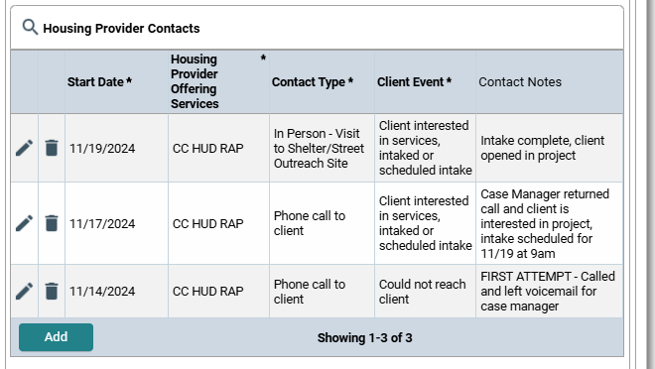
____________________________________________________________________________________________
Questions? Email Ryan or Cass at the HHC!
rkash@hhccny.org cmontressor@hhccny.org

